We will be sharing the grounds with the The Connecticut Valley of Vizsla Club There will be four separate Hunt Tests with four separate premiums, which means that you can enter four tests in a single weekend. Entries MUST be sent to the appropriate secretary for each club. Their premium is available at:

www.ctvalleyvizslaclub.org

PANE Premium will be available at:

http://www.eastconn.com/pane/

***Note that the starting time is different
for each test on each day***

Saturday, October 5, 2013
***Junior Hunting Test at 1:00 PM***
***Master Hunting Test at 1:00 PM, Senior to follow***

Sunday, October 6, 2013
***Junior Hunting Test at 7:30 AM***
***Master Hunting Test at 7:30 AM, Senior to follow***

Emergency, Police, Ambulance & Fire 911, Vet on call W. MA 413-783-0603

Hunt Test PREMIUM LIST Event # 2013432307

Pointer Associates of New England

AKC LICENSED
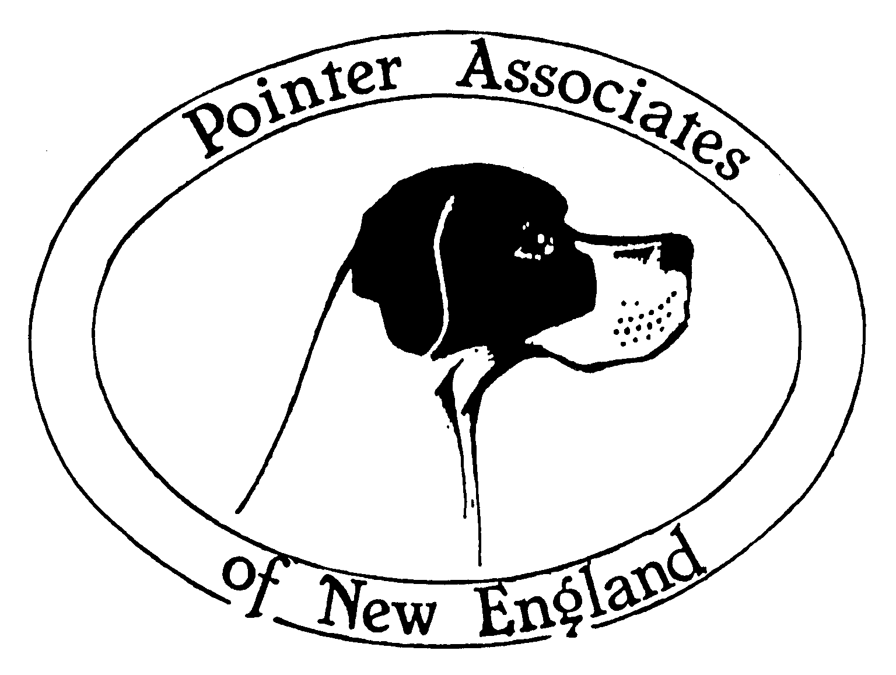

John E. Flaherty Field Trial Area

Tromley Road, E. Windsor, CT 06088
Sunday October 6, 2013
**** Closes Wednesday October 2 at 6:00 p.m.****

ALL STAKES
OPEN TO ALL AKC REGISTERED POINTING BREEDS

ENTRIES LIMITED ENTER EARLY!!!
Senior/Master Entries are limited to 7 braces (14 dogs) each day.
Junior Entries are limited to 15 braces (30 dogs) each day.

This Hunt Test is held under Rules and Procedures of the AMERICAN KENNEL CLUB

MAIL ADVANCE ENTRIES WITH CHECKS Payable to
Pointer Associates of New England, Inc. To: Debby Freidus, 388 Burlington Road, Harwinton, CT 06791 860-485-0323 blackthornpt@earthlink.net
Phone & E-mail entries accepted- must be confirmed by email reply.

Entries and checks must be in before dog is drawn
Please include email on entry form to receive a copy of the running order via email
ENTRIES WILL CLOSE AT 6:00 P.M. (EST), Wednesday, October, 2, 2013
At 388 Burlington Road, Harwinton, CT 06791
Drawing will take place at 7 P.M. (EST) Wednesday, Oct. 2, 2013 at
388 Burlington Road, Harwinton, CT 06791 860-485-0323

JUDGES AND STAKES TO BE JUDGED
Louis B Boyatzi, 19087, 270 Tom Swamp Rd, Petersham, MA Master/Senior Hunter A
Christopher Sweetwood, 67709,12 Manor House Lm,Milford, CT Master/Senior Hunter A
Lauren Friedman, 75130, 12 Manor House Lm, , Milford, CT Master/Senior Hunter B
Denise Cooper, 93545, 421 Daventry Rd, Berwyn, PA Master/Senior Hunter B
Jim Dougherty, Z8299, 10 Mary Belle Cir, Ledyard, CT Junior Hunter A
Dianne Tuttle, ZG617, 10 Petticoat Lane, Broad Brook, CT Junior Hunter A
James A McWalter, 94008, 55 Puritan Rd, Pembroke, MA Junior Hunter B
Peggy Aguiar, 94884, 3 Hearth Side Circle, Bedford, NH Junior Hunter B

Gunners
Audra Jaconetti Aaron Crown

STAKES, SCHEDULE AND ENTRY FEES

Master Hunter Not Before 7:30 AM, Sun. Oct 6, 2013 $43
Senior Hunter To follow the start of Master Hunter $43
Junior Hunter Not before 7:30 PAM Sun. Oct 6, 2013 $40

COURSES AND BIRDS
Master & Senior Hunter course with bird field 30 minutes
Junior Hunter separate course with bird field 15 minutes
Liberated quail and/or chucker for all tests.
Native birds may be encountered.
Only blank pistols will be fired, except for official gunners
All gunning in the designated bird field by official gunners.

Prizes: Standard AKC orange rosettes awarded to dogs receiving qualifying score
Blaze orange required of all participants on course.
Five minute brace call will be strictly enforced.
Please check in with secretary upon arrival

Hunt Test Chairman- Susan Gregory
Hunt Test Secretary- Cathy Rounds, 296 River Road, Putney, VT 05346
PHONE 802-387-5073 or e-mail rounds_c@yahoo.com

Hunt Test Committee

Susan Gregory, Cathy Rounds, Cheryl Buchanan,

Sheila Kelle, Matt Sisk, Debra Freidus, Paul Zapun

Officers
Cathy Rounds, President, 296 River Road, Putney, VT 05346
Susan Gregory, Vice President, 17 Graf Road, Newburyport, MA

Judith Hamilton, Treasurer, PO Box 2101, Palm City, FL

Cheryl Buchanan, Secretary, 375 Beckers Corners Road, Sloansville, NY

Directions:
Take Route 91 exit 44. Follow RT 5 South approximately 1.5 miles. Take a left on Tromley Road. Grounds are 1/3 mile on left (sign on right).

Breakfast & Lunch available on grounds for purchase.

Drinking water available for people & dogs.

Tracking collars allowed per AKC rules & regulations, but will not be
provided by Pointer Associates of New England

Motels: Holiday Inn Express I-91exit 44, E. Windsor, CT 860-627-6585
Clarion Inn & Suites I-91 exit 45, E. Windsor, CT 860-623-9411
Motel 6 I-91 exit 47, Enfield, CT 860-741-6585
Best Western I-91 exit 45 860 623-9411
Super 8 Motel I-91 exit 46 860- 741-3636

OFFICIAL AMERICAN KENNEL CLUB FIELD TRIAL or HUNT TEST ENTRY FORM
Club  Pointer Associates of New England |  |  | Date: Oct 6, 2013 / Event # 2013432307
Location: E. Windsor, CT |  |  | Event type (test or trial):Hunt Test
Enter in Stake/Test: |  |  | I enclose fees  in the amount of: $ _____________________
Breed: | Reg #: |  |  |  | Sex: |  | Date of Birth:
AKC No.. AKC Litter No ILP No.
Foreign # & country: ______ Call Name:
____________________
Full Name of Dog:
Sire:
Dam:
Name of Breeder
Actual Owner(s):
Owner’s Address:
City: |  |  |  | State: |  | Zip:
Name of Owner’s Agent/Handler:
AKC Rules, Regulations, Policies and Guidelines are available on the American Kennel Club website: www.akc.org
AGREEMENT
I (we) agree that the club holding this event has the right to refuse this entry for causes which the club shall deem sufficient. In consideration of the acceptance of this entry and of the holding of this event and of the opportunity to have the dog judged and to win prizes, ribbons, or trophies, I (we) agree to hold the AKC, the event-giving club, their members, directors, governors, officers, agents, superintendents or event secretary and the owner and/or lessor of the premises and any provider of services that are necessary to hold this event and any employees or volunteers of the aforementioned parties and any AKC approved judge, judging at this event, harmless from any claim for loss or injury which may be alleged to have been caused directly or indirectly to any person or thing by the act of this dog while in or about the event premises or grounds or near any entrance thereto, and I (we) personally assume all responsibility and liability for any such claim: and I (we) further agree to hold the aforementioned parties harmless from any claim for loss, injury or damage to this dog.
Additionally, I (we) hereby assume the sole responsibility for and agree to indemnify, defend and save the aforementioned parties harmless from any and all loss and expense (including legal fees) by reason of the liability imposed by law upon any of the aforementioned parties for damage because of bodily injuries, including death at any time resulting therefrom, sustained by any person or persons, including myself (ourselves), or on account of damage to property, arising out of or in consequence of my (our) participation in this event, however such injuries, death or property damage may be caused, and whether or not the same may have been caused or may be alleged to have been caused by the negligence of the aforementioned parties or any of their employees, agents, or any other persons. I (WE) AGREE THAT ANY CAUSE OF ACTION, CONTROVERSY OR CLAIM ARISING OUT OF OR RELATED TO THE ENTRY, EXHIBITION OR ATTENDANCE AT THE EVENT BETWEEN THE AKC AND MYSELF (OURSELVES) OR AS TO THE CONSTRUCTION, INTERPRETATION AND EFFECT OF THIS AGREEMENT SHALL BE SETTLED BY ARBITRATION PURSUANT TO THE APPLICABLE RULES OF THE AMERICAN ARBITRATION ASSOCIATION. HOWEVER, PRIOR TO ARBITRATION ALL APPLICABLE AKC BYLAWS, RULES, REGULATIONS AND PROCEDURES MUST FIRST BE FOLLOWED AS SET FORTH IN THE AKC CHARTER AND BYLAWS, RULES, REGULATIONS, PUBLISHED POLICIES AND GUIDELINES.
Signature of owner or his
agent duly authorized to make this entry: ______________________________________________
Telephone: |  | Email address:

